**Đề luyện 3_đáp án**

**#1 Recall the activity that removes the cause of a failure.**

a. Testing

b. Dynamic testing

**c. Debugging**

d. Reverse engineering

**#2 What is the activity of comparing the planned test progress to the actual test progress?**

**a. Test control**

b. Test planning

c. Test closure

d. Control cycling

**#3 As a tester, which of the following is a key to effectively communicate and maintain positive relationships with developers when there is disagreement over the prioritization of a defect?**

a. Escalate the issue to human resources and stress the importance of mutual respect

b. Communicate in a setting with senior management to ensure everyone understands

c. Convince the developer to accept the blame for the mistake

**d. Remind them of the common goal of creating quality systems**

**#4 Which of the following is an important objective of the testing activities in the software development lifecycle?**

a. Exhaustive testing

**b. Providing decision-making information**

c. Clustering defects

d. Debugging

**#5 In what way does root cause analysis contribute to process improvement?**

**a. Helps to better identify and correct the root cause of defects**

b. Outlines how development teams can code faster

c. Specifies the desired root causes to be achieved by other teams

d. Contributes to the justification of future project funding

**#6 Why is it important to avoid the pesticide paradox?**

a. Dynamic testing is less reliable in finding bugs

b. Pesticides mixed with static testing can allow bugs to escape detection

c. Tests should not be context dependent

**d. Running the same tests over and over will reduce the chance of finding new defects**

**#7 Why is software testing sometimes required for legal reasons?**

a. It prevents developers from suing testers

**b. Contracts may specify testing requirements that must be fulfilled**

c. International laws require software testing for exported products

d. Testing across systems must be accompanied by legal documentation

**#8 Which of the following is a characteristic of a well-managed test level?**

a. It has a target duration of one month

**b. It has a corresponding test objective**

c. It does not overlap with another test level

d. It applies a single test design technique

**#9 Non-functional testing may be performed at which test level(s)?**

**a. Unit, integration, system and acceptance**

b. Unit and integration

c. Load and performance

d. Unit, integration, and system

**#10 When a system is targeted for decommissioning, what type of maintenance testing may be required?**

a. Retirement testing

b. Regression testing

**c. Data migration testing**

d. Patch testing

**#11 Which test activity should occur early in the software development lifecycle?**

a. Test readiness review

b. Defect prioritization

c. Acceptance testing

**d. Documentation reviews**

**#12 Which test activity is most appropriate when a minor modification has been applied to an existing system or program?**

a. Apply patches to the system to ensure it is up to date

**b. Perform a regression test to uncover defects that may be a result of the modification**

c. Execute non-functional testing to ensure system reliability

d. Perform a backward-compatibility test with the old system as a contingency

**#13 What is the purpose of performing regression testing when system maintenance activities have occurred?**

**a. To ensure the overall system has not regressed**

b. To ensure no unauthorized changes have been applied to the system

c. To assess the scope of maintenance performed on the system

d. To identify any maintainability issues with the code

**#14 Which of the following techniques is a form of static analysis?**

a. Error guessing

b. Manual regression testing

c. Providing inputs and examining the resulting outputs

**d. Manual examination of documentation**

**#15 What is the primary purpose of conducting static analysis?**

a. To determine usability

b. To reduce scope expansion

**c. To detect defects early**

d. To eliminate reliance on compliers

**#16 Which of the following is a benefit from static analysis?**

**a. Defects can be identified in documentation that might not be caught by dynamic testing**

b. Early defect identification requires less documentation

c. Early execution of the code provides a gauge of code quality

d. Tools are not needed because reviews are used instead of executing code

**#17 If your goal is to achieve 100% decision coverage, what testing technique are you using?**

a. Behavior-based

**b. Structure-based**

c. Experience-based

d. Defect-based

**#18 Which of the following test techniques uses the requirements specifications as the test basis?**

a. Structure-based

**b. Black-box**

c. White-box

d. Exploratory

**#19 Which of the following is an experience-based testing technique?**

**a. Error guessing**

b. Intuition testing

c. Acceptance testing

d. Exhaustive testing

**#20 Which of the following is considered a less formal test technique typically used in conjunction with other, more formal techniques?**

a. Structure-based

b. Static analysis

**c. Experience-based**

d. Risk-based

**#21 Which of the following is a correct statement?**

a. A test condition tests a test procedure by following a test case

**b. A test case tests a test condition by following a test procedure**

c. A test procedure tests a test case by following a test condition

d. A test condition, a test case and a test procedure are all the same

**#22 How is statement coverage determined?**

a. Number of test decision points divided by the number of test cases

b. Number of decision outcomes tested divided by the total number of decision outcomes

c. Number of possible test case outcomes divided by the total number of function points

**d. Number of executable statements tested divided by the total number of executable statements**

**#23 Which of the following is the correct decision table for the following pseudocode for ordering a hamburger?**

Note: if you add or delete items from the basic burger, you no longer get the basic burger.

Start

Select basic burger

If customer adds items

While items to be added

Ask customer which item

Add item

End while

Endif

If customer deletes items

While items to be deleted

Ask customer which item

Delete item

End while

Endif

If customer wants fries

Add fries to order

Endif

Complete order

End

**Đáp án B**

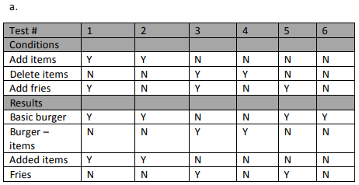

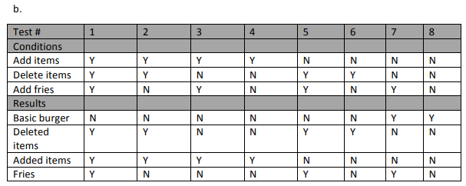

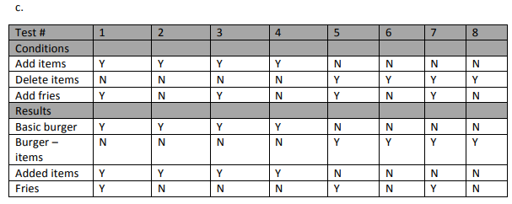

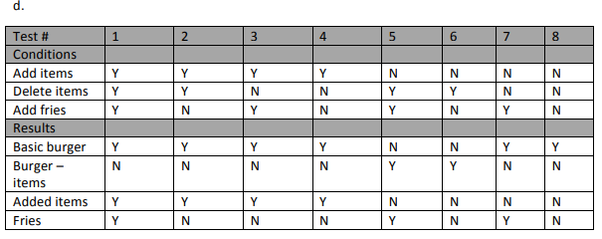

**#24 You are testing a scale system that determines shipping rates for a regional web-based auto parts distributor**.

You want to group your test conditions to minimize the testing.

Identify how many equivalence classes are necessary for the following range. Weights are rounded to the nearest pound.

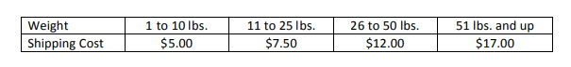a. 8

b. 6

**c. 5**

d. 4

**#25 Consider the following control flow chart:**

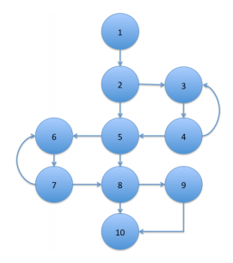

You have run one test case:

1-2-3-4-5-6-7-8-9-10

What percentage of statement coverage have you achieved?

a. 50%

b. 80%

c. 90%

**d. 100%**

**#26. Same as Question #25**

You have run one test case:

1-2-3-4-5-6-7-8-9-10

What percentage of decision coverage have you achieved?

**a. 50%**

b. 80%

c. 90%

d. 100%

**#27 You are testing a scale system that determines shipping rates for a regional web-based auto parts distributor.**

Due to regulations, shipments cannot exceed 100 lbs. You want to include boundary value analysis as part of your black-box test design.

How many tests will you need to execute to achieve 100% boundary value analysis?



a. 4

b. 8

**c. 10**

d. 12

**#28 Evaluate the following control flow diagram and determine the statement coverage and decision coverage resulting from the execution of the following test cases:**

A-B-D-E-F

A-B-C

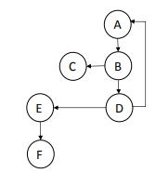

a. 33% statement, 100% decision

b. 50% statement, 50% decision

**c. 100% statement, 75% decision**

d. 100% statement, 100% decision

**#29 Level of risk is determined by which of the following?**

**a. Likelihood and impact**

b. Priority and risk rating

c. Probability and practicality

d. Risk identification and mitigation

**#30 Which of the following is a project risk?**

a. A defect that is causing a performance issue

b. A duplicate requirement

c. An issue with a data conversion procedure

**d. A schedule that requires work during Christmas shutdown**

**#31 What is the biggest problem with a developer testing his own code?**

a. Developers are not good testers

b. Developers are not quality focused

**c. Developers are not objective about their own code**

d. Developers do not have time to test their own code

**#32 Which of the following is a drawback with having independent testing done by independent testers?**

**a. The testers may be seen as bottlenecks in the release process**

b. The developers will have to do most of the testing anyway

c. The testers will provide a quality-focused perspective

d. The developers will have to spend significant time training the testers

**#33 Which of the IEEE 829 documents may refine the test approach?**

a. The test plan

**b. The test design specification**

c. The test procedure specification

d. The test case specification

**#34 What is the purpose of tracking defect density?**

a. To determine the number of high priority defects

b. To determine the trend in high severity defects

**c. To determine the areas that have the higher numbers of defects**

d. To predict when the open defects found and the defects fixed numbers will converge

**#35 Consider the following test cases that are used to test an accounting system:**

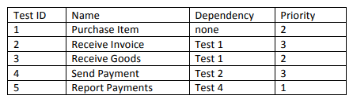

Given this information, what is the proper order in which to execute these test cases?

a. 5, 1, 3, 2, 4

b. 1, 2, 4, 3, 5

**c. 1, 3, 2, 4, 5**

d. 3, 4, 5, 1, 2

**#36 You have been testing software that will be used to track credit card purchases.**

You have found a defect that causes the system to crash, but only if a person has made and voided 10 purchases in a row.

What would be the proper priority and severity rating for this defect?

a. Priority high, severity high

b. Priority high, severity low

c. Priority low, severity low

**d. Priority low, severity high**

**#37 What is the primary purpose of a test execution tool?**

**a. It executes test objects using automated test scripts**

b. It automatically records defects to the defect tracking system

c. It analyzes code to determine if there are any coding standard violations

d. It tracks test cases, defects and requirements traceability

**#38 Which of the following are the major objectives of a pilot project for a tool introduction?**

a. Roll out, adapt, train, implement

b. Monitor, support, revise, implement

**c. Learn, evaluate, decide, assess**

d. Evaluate, adapt, monitor, support

**#39 What is the main goal of a proof of concept for a new tool?**

a. To see if people find it usable

**b. To see if it works with the organization’s infrastructure**

c. To see if management is happy with the licensing structure

d. To see if the vendor will supply adequate support

**#40 If you are looking for a tool that will verify if the code complies with coding standards, what type of tool are you seeking?**

a. Test management

b. Test automation

**c. Static analysis**

d. Keyword-driven